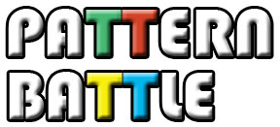

**Game Design Document**

By: Cary Walkin

Latest Revision: October 16, 2013

Contents

Executive Summary 3

Game Modes 3

Single Player Mode 3

Multiplayer Mode 4

Programming Logic 5

Game Mechanics and Tiers 5

Classic 6

Gestures (Flick and Drag) 6

Rotation 7

Colour Swap 7

Ultimate 7

Unlock Artifact Award System 8

Unlock Artifact Uses 8

Monetization 10

In-app Purchases 10

Advertisements and Paid Version 10

Back-end Server Expenses 10

Financial Forecast 10

Project Planning 12

Major Tasks 12

Resources 12

Time Estimates 12

# Executive Summary

Pattern Battle is an innovation of the well known pattern matching game, Simon. Pattern Battle is a pattern matching game that increases in difficulty as new game mechanics are unlocked by the player. For example, each pattern iteration successfully completed awards the player a new Unlock Artifact (**See "Unlock Artifact Award System"**). A number of Unlock Artifacts are required to unlock new game mechanics that increase the degree of challenge. These include game rotation, colour swap, and gestures (**See "Game Mechanics and Tiers"**). These game mechanics require the player to keep track of not only the pattern itself, but also how to interact with the pattern. The number of Unlock Artifacts required to unlock a game mechanic scale with the effectiveness of the game mechanic to ensure proper balancing while progressing through the game. As the new game mechanics are unlocked, they also become available in multiplayer to be used in a 1 versus 1 turn-based "Pattern Battle" where each player tries to create a complex pattern to defeat their opponent (**See "Game Modes"**).

The game is designed for touch devices such as iOS, Android, and tablets. The business model includes in-game advertisements in a free version, as well as in-app purchases for bundles of Unlock Artifacts. The focus is skill-tested monetization, rather than patience-tested monetization, to encourage a player to continue playing rather than getting frustrated.

# Game Modes

The game has 2 game modes: Single Player mode and Multiplayer mode.

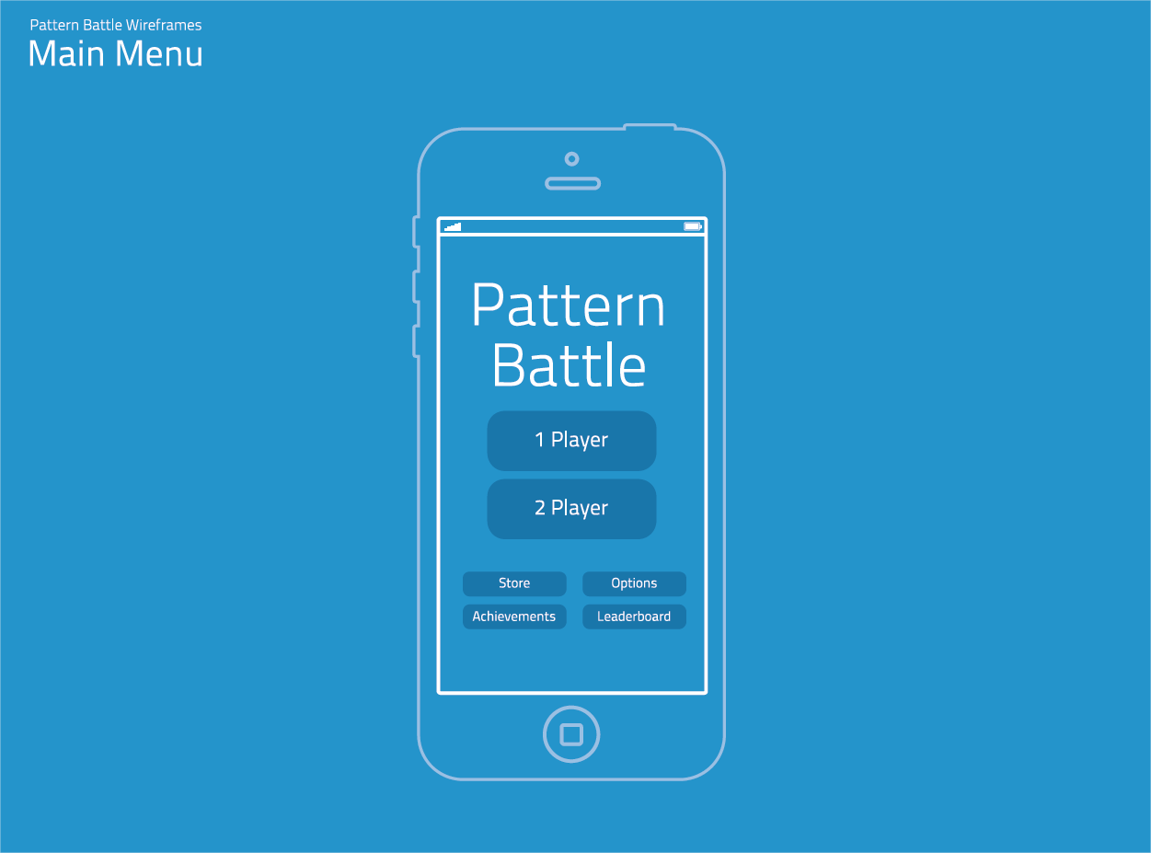

## Single Player Mode

This mode pits the player against a completely randomized AI. The player chooses the appropriate tier that has been unlocked and the AI is bound to the mechanics in that tier (**See "Game Mechanics and Tiers"**). A turn in single player mode consists of the AI dictating a pattern of button activations to the player and then prompting the player to repeat the pattern. If the player successfully repeats the pattern, the AI will then append 1 new button activation (within the game mechanic parameters if applicable) to the next pattern. The game continues until the player eventually fails to repeat the pattern. The game keeps track of the player's current score and the player's high score for that specific mechanic difficulty. Score is defined as the number of successful turns the player has completed.

## Multiplayer Mode

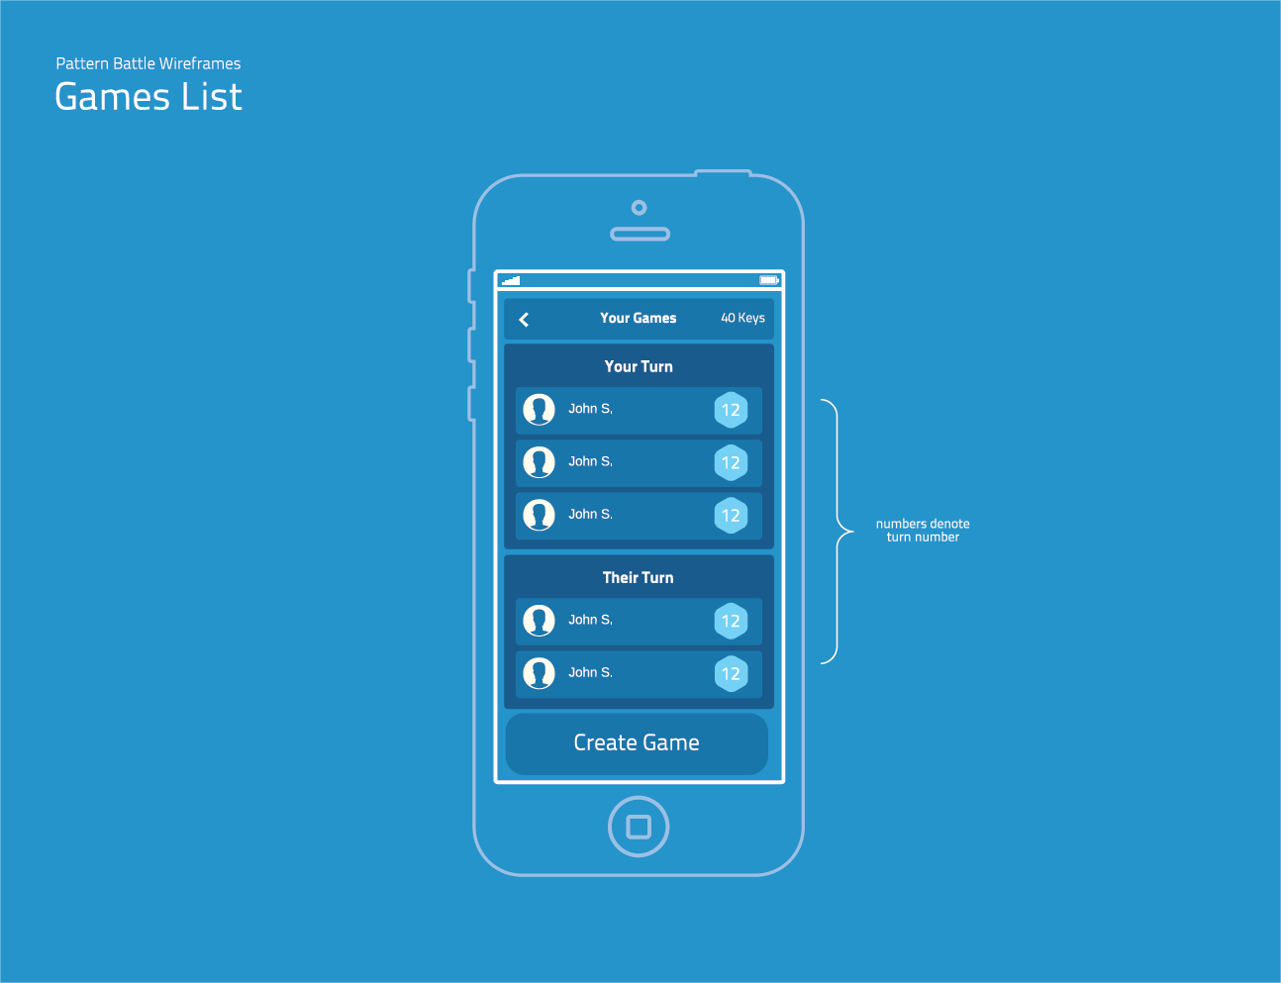

This mode consists of a 1v1 "Pattern Battle" with either randomized opponents or games initiated with contacts or friends through social media such as Facebook or Apple's Game Center. This feature will require integration with the social network API. This will also require the player to have an online connection, to communicate with the server. For security and privacy reasons, the objective is for us to never have access to player login credentials. Non-Facebook players are given the option of a guest account based on unique system identifiers.

Multiplayer mode has the option to start a game against a friend or a random opponent. If the player selects start a game with a friend, the game starts immediately on the player's screen. The player (Player 1) plays their first "turn" to start the pattern. "Turn" for multiplayer mode is defined as 2 taps and a game mechanic. For example, a starting turn may be RED - BLUE - DRAG RED TO GREEN. Game mechanics can be used at any point in the turn, at the player's discretion. Game mechanics can only be used if they have been unlocked previously with Unlock Artifacts. If there are no game mechanics unlocked, the player's game mechanic move becomes another tap. The starting turn consists of 3 moves from the player. Once the starting turn is completed, Player 1's pattern is sent to the server and a notification is sent to the opponent (Player 2) that they have been challenged to a Pattern Battle. Player 2 will see Player 1's starting pattern and will need to match it in order for Player 2's turn to add additional movements to the pattern. When complete, Player 2's pattern is sent to the server and a notification is then sent back to Player 1 and this continues until one player fails to match the pattern set by the other player. Once a game is complete, a notification with option for a rematch is sent to both players and Unlock Artifacts are awarded as applicable (**See "Unlock Artifact Award System"**).

If a player selects the option to play against a random opponent, the client checks the server to see if there are any other players currently in queue to play a multiplayer match. If not, the player is added to the queue and notified that their game will start once another player has been found. If a match has been found, the game begins and the player gets the starting turn. The game then continues as described in the paragraph above.

Players in multiplayer mode will also have a levelling treadmill attached to their profile. The level is entirely for vanity purposes and there are no rewards associated with levelling up. Each multiplayer win is worth 100 XP, each multiplayer loss is worth 10 XP. The XP required to gain a level is represented by the formula: $25 ×{player_level}^{2}+100$.

# Programming Logic

Each button is a round object that has the following properties:

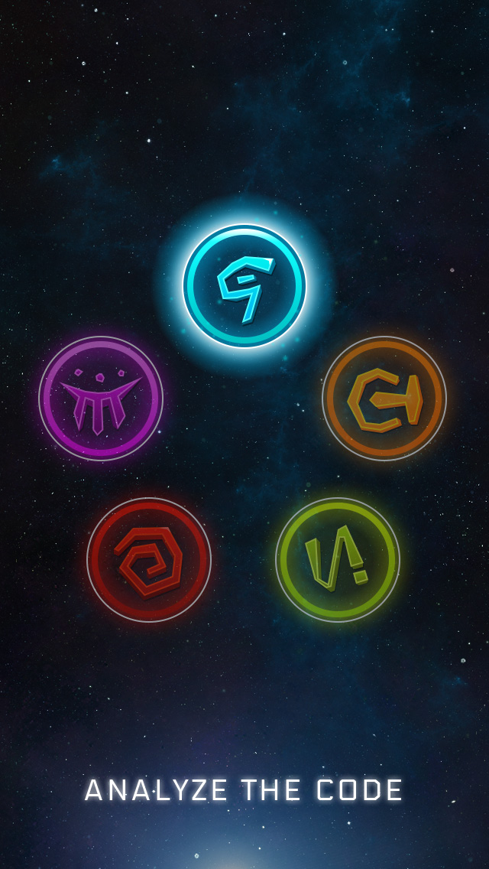

* Colour - stores the current colour of the button.
* Position - stores the current relative position of the button in sequential order (starting at the top-left and incrementing clockwise).

The pattern to be matched is stored independently of the objects and does not change when the objects change but rather gets appended with the new object data as the pattern grows. For example, in a scenario where the pattern is: Blue Button in Position 1, Game rotates counter clockwise, Yellow Button in Position 1 the pattern to be matched can be written as a string "B1.CC.Y1." where periods indicate a completed match and square brackets indicate game mechanic instructions that will automatically occur before seeking the next input from the player (only applicable for the Colour Swap game mechanic). Note that the pattern matching string is independent of where buttons were historically and only cares about where they are currently. Note that we do not care that the Yellow Button was in Position 2 before it became part of the pattern. This allows for the dynamic game mechanics to be tracked easily. In a multiplayer game, this string is stored on a server to facilitate turn-based multiplayer. There is never direct peer to peer communication between players, only between the player and the server.

# Game Mechanics and Tiers

All game mechanics are unlockable in single-player. The player progresses through a series of challenges. Each new challenge which sometimes includes new mechanics is unlocked by expending artifacts. Multiplayer allows the player to expend artifacts at any time in order to add a “special” move to the puzzle sequence.

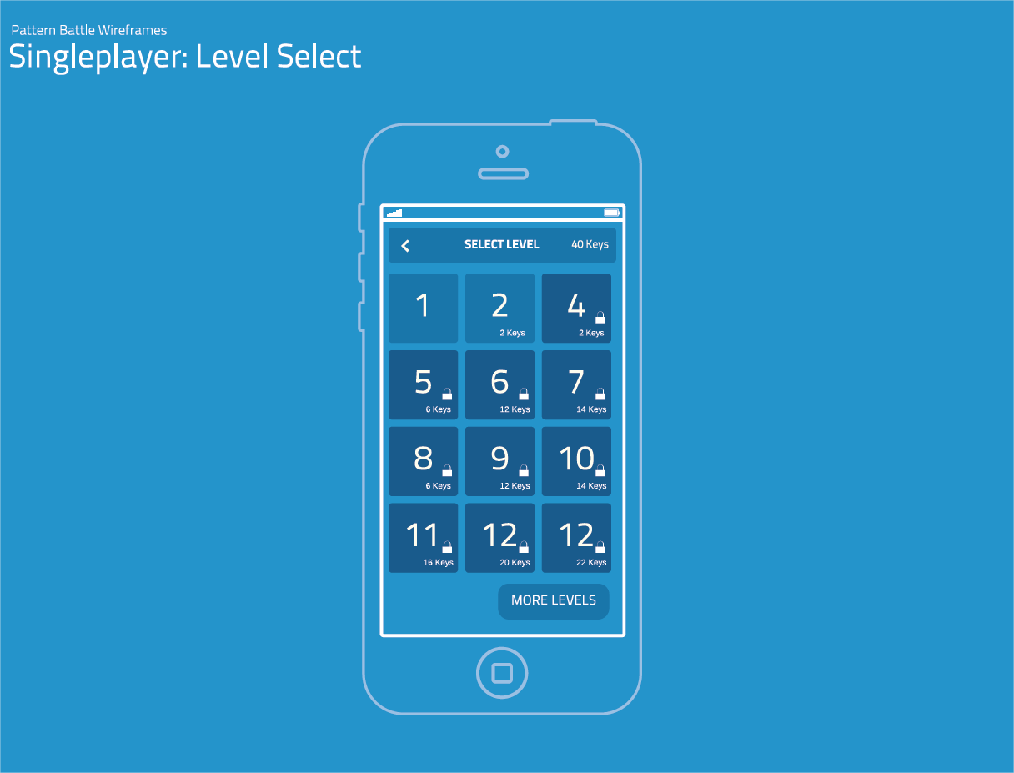

The different levels can be thought of as falling under the following loose categories:

## Classic

Classic is a game mechanic whereby a pattern appears and the player repeats the pattern by tapping the buttons in the correct sequence. For example, if the pattern is RED-BLUE-RED, the screen will flash RED, then BLUE, then RED. In order to successfully complete the pattern, the player must tap RED then BLUE and then RED. Tapping a button out of sequence will cause the game to be over. If the player completes the pattern, another button is incremented to the pattern sequence and the pattern is visually displayed for the player's next turn.

## Gestures (Flick and Drag)

This game mechanic tier introduces two new ways to interact with the buttons in the pattern. This changes the way that the player must think about the pattern: now they must also remember how they interact with the buttons to complete the pattern. For example in the pattern RED - FLICK GREEN - DRAG BLUE TO RED, a pattern of 3 steps has become more difficult as the player must tap the red button, flick the green button and then drag the blue button to the red button. Drag gestures are visually indicated on screen by a finger thick line between two buttons. The line is a visual gradient of the button colours and small triangles along the line indicate which direction the drag gesture should be performed.

Flick gestures are visually indicated on the screen by a button lighting up and being flung away from the other buttons. It will then gradually return to the starting position using spring physics to accurately "bounce" around the screen.

## Rotation

This game mechanic tier introduces rotation as a new way to interact as part of the pattern. Rotation requires the player to swipe along the perimeter of the screen to rotate all of the buttons either 90 degrees clockwise or 90 degrees counter-clockwise. This mechanic will need to support multi-touch if a player uses two fingers to rotate the buttons however only one finger swipe is actually required. Note that the device's orientation is not being used as an input device for the rotation mechanic. Rotations are visually indicated by all buttons moving clockwise or counter clockwise to their new locations.

## Colour Swap

This game mechanic tier requires the player to change the way that they remember the pattern. The player must focus on where the correct button is located in the pattern rather than the historical colour of that button as the colour of all buttons will randomly change throughout the pattern. For example, in the pattern of RED-1 [COLOUR SWAP of RED-1 to CYAN-1] BLUE-2 [COLOUR SWAP of GREEN-3 to RED-3] CYAN-1: The pattern is only 3 buttons long however the player needs to keep track of the locations of the buttons (in the example above, the locations of the pattern are 1-2-1). After the first colour swap, the player can no longer use red as a psychological anchor and it no longer appears on the screen even though they had to remember it as part of the pattern. After the second colour swap, RED has come back as a colour but is now in a different position and is irrelevant to the rest of the pattern. This acts as a temporary distraction which requires the player to really focus on the pattern in a way that they did not have to historically. For the programming logic, there are 12 predefined colours (such as Cyan, Magenta, Gold, etc.) that have a boolean status that indicates whether or not they are currently in use. The colour swap randomly chooses a colour from the pool of inactive colours and switches it with a colour currently in use on one of the buttons.

## Ultimate

Ultimate is a tier that is the randomized combination of all aforementioned game mechanics and can only be unlocked after all other game mechanics have been unlocked. In each tier prior to Ultimate, the player only has to deal with one game mechanic at a time. Ultimate challenges the player by randomly presenting them with different mechanics between each part of the pattern. This is effectively the "end-game" of Pattern Battle and is significantly challenging.

# Unlock Artifact Award System

Unlock Artifacts are awarded after the following events:

* 1 Unlock Artifact is awarded for winning a multiplayer game after at least 2 turns. 2 Unlock Artifacts are awarded for winning a multiplayer game after at least 5 turns. 3 Unlock Artifacts are awarded for winning a multiplayer game after at least 9 turns.
* 1 Unlock Artifact is awarded for losing a multiplayer game that has gone at least 5 turns. 2 Unlock Artifacts are awarded for losing a multiplayer game after at least 9 turns.
* Artifacts are rewarded in various quantities for success on a given single player level.

## Unlock Artifact Uses

A significant number of unlock artifacts can be used for a one-time purchase to unlock game mechanics in multiplayer and single player modes, as described in "**Game Mechanics and Tiers"**. Unlock artifacts can also be used repetitively to:

* Unlocking a new Single Player Challenge
* Initiate a pre-attempt *Replay*: This option is available for both multiplayer and single player modes. It will cause the pattern to repeat itself to the player. This is useful if the player got flustered at the complexity of the pattern and wants to watch it again before attempting to solve. Once the player begins to solve the pattern, this option is no longer available. The cost of a replay increases incrementally with the frequency that replays have been used in the current match. For example, the sequence of costs could be: 1,2,3,5,8,13, etc.
* Initiate a *Do-Over*: This is a single player only option. This option appears for a 3 second duration after the player has failed to solve the pattern. This allows the player to try again and the pattern will replay itself. The cost of this option is always double the cost of a pre-attempt replay.
* Initiate a *Power Turn*: This is a multiplayer only option. This allows a player to have all 3 of their moves in a turn be game mechanic moves. For example, if a player selects the Power Turn option and then Gestures, they can flick and/or drag 3 times for their turn. This option appears after a player has solved their opponent's pattern and before the player has started adding their own pattern. If the player has unlocked the Ultimate game mechanic tier, they can have different game mechanics for each of their 3 moves. The cost of a Power Turn increases incrementally with the frequency that Power Turns are used in the match. (cancelled, as a player can add as many moves as they like so long as they have keys.)
* All Moves in Multiplayer aside from tap cost keys to add.
* Initiate an *Extra Move*: This is a multiplayer only option. This allows the player to have an additional move during their turn. Instead of the typical 3 moves per turn, the player can now add a 4th element to the pattern. Note that this can only be used once per turn. The cost of an Extra Move increases incrementally with the frequency that Extra Moves are used in the match.

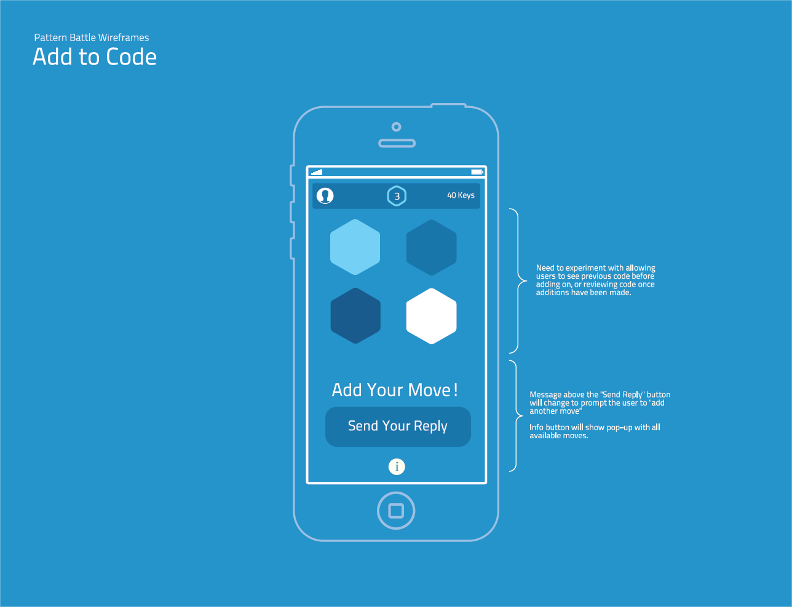

Note that when the player selects a button on the bottom ribbon, both the top and button ribbons swipe off of the screen to allow the player more screen room to execute their move.

# Monetization

## In-app Purchases

Unlock Artifacts can be purchased in the following packages: TBC

* 10 Unlock Artifacts for $0.99
* 50 Unlock Artifacts for $4.49
* 100 Unlock Artifacts for $7.99
* 250 Unlock Artifacts for $16.99

Conversions and comparative market data will need to be done for localized pricing in international markets.

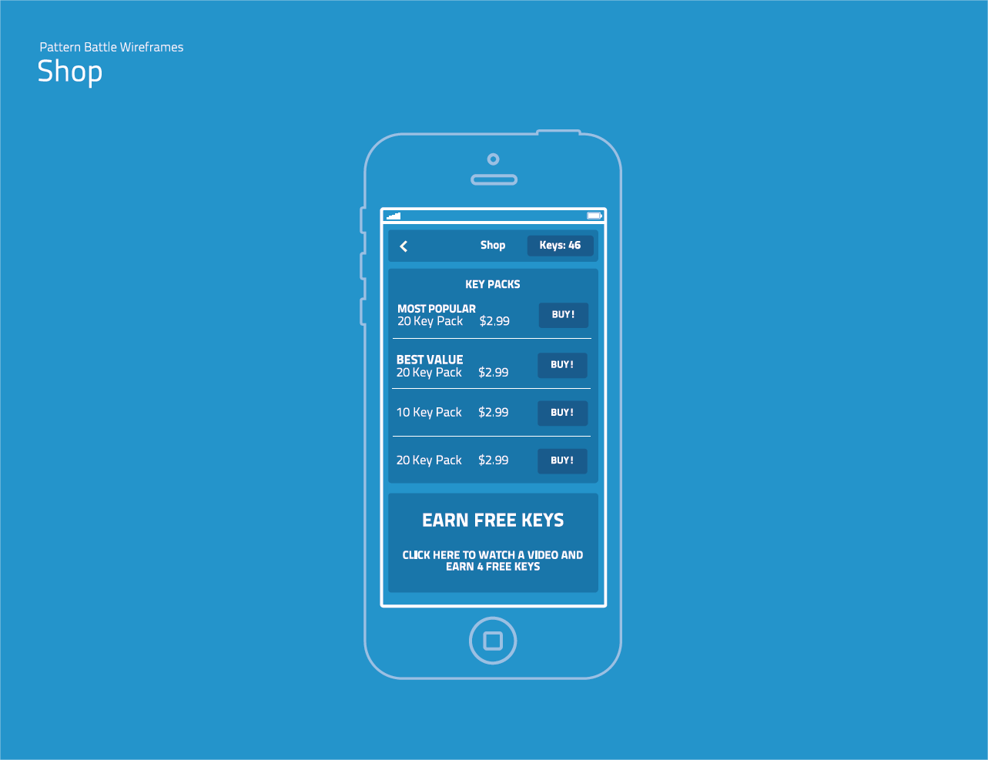

## Advertisements and Paid Version

A free version of the game will contain interstitial advertisements between turns in single player and multiplayer mode (maximum frequency of 1 interstitial advertisement per minute). A paid version of the game will contain no advertisements and cost between $0.99 and $2.99.

## Back-end Server Expenses

There are a variety of scalable services available from third-parties that explicitly advertise Unity support. For example Gamooga (www.gamooga.com) offers packages from $0/month to $1,900/month depending on incoming message volume / data transfer requirements. This scalability will allow for minimal expense overhead in a scenario where the game does not take off, as well as allowing the flexibility to increase capacity in a scenario where the game does take off.

## Financial Forecast

The following financial forecast examines 5 different scenarios using data from comparable games ranked between 500 to 100 on the top games listing at their respective stores. It is important to note that the ranking system is subject to short-term fluctuations in downloads per day, and as such an individual ranking is not indicative of a game's long-term success or gross revenue. This forecast should not be relied upon as an accurate predictor of specific events and should only be used as a range of possible outcomes.



# Project Planning

## Major Tasks

* Touch input controls programming for the various game mechanics
* Support for in-app purchases
* Support for in-game interstitial advertisements (in the free version only)
* Integration with Facebook API and Game Center API
* Integration with a back-end service provider to support turn-based multiplayer
* User Interface artwork
* Particle effects that highlight correct button presses
* Analytics programming to assess how players are using the game

## Resources

Lead Game Designer - Cary Walkin

Spring physics documentation and formulas - <http://www.physicsclassroom.com/class/waves/u10l0d.cfm>

## Time Estimates

The project should be completed within 1-3 months depending on the skill and scope of resources available.